**New Document**

***Crypto***

**Challenge:**

You’ve received what appears to be an errant email containing just a black word document from someone you know. Off the record however, they’ve suggested there’s more to this document than meets the eye.

Attached - Document1.rtf

**Approach:**

First of all, for those who don’t know what .rtf files are, read this: <https://en.wikipedia.org/wiki/Rich_Text_Format>

Secondly, we are not going to use any of that knowledge here :)

I did what I do with any file on any CTF, open it up on a notepad :)

We see a lot of (not required) text that has nothing to do with the flag, and we obv cant go through each sentence now right?

Ctrl+F == Find

We know the flag starts with the prefix: “CaptureTheWu”

And there we go…

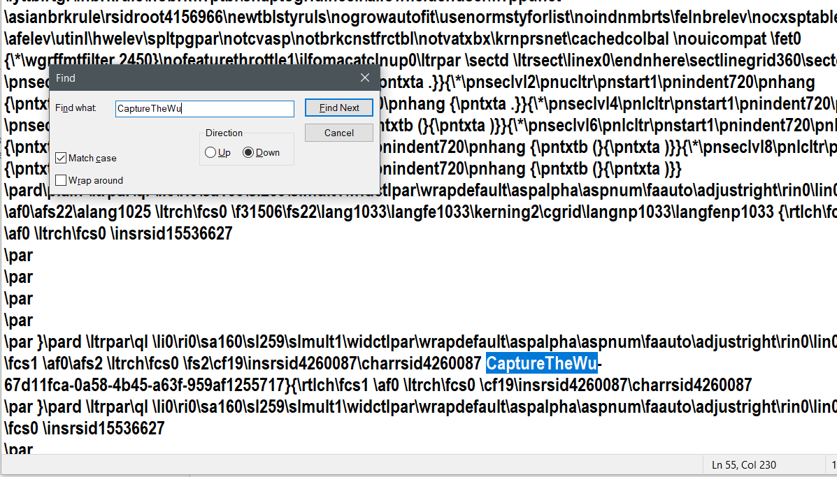

**Flag: CaptureTheWu-67d11fca-0a58-4b45-a63f-959af1255717**

(Again, this might not be the intended way to solve this, but i believe going through the notepad once is always worth it.)

Congrats!!

Happy Hacking!